GRADING OF STUDENTS:

1. GRADING OF STUDENTS USING CONDITIONAL STATEMENTS:

DECLARE

V_NAME VARCHAR(20);

SCORE INT;

BEGIN

V_NAME:=:V_NAME;

SCORE:=:SCORE;

IF SCORE >=90 THEN

DBMS_OUTPUT.PUT_LINE('OUTSTANDING');

ELSIF SCORE>80 AND SCORE<89 THEN

dBMS_OUTPUT.PUT_LINE('DISTINCTION');

ELSIF SCORE>= 70 AND SCORE<=79 THEN

dBMS_OUTPUT.PUT_LINE('GOOD GRADE');

ELSIF SCORE>=60 AND SCORE<=69 THEN

dBMS_OUTPUT.PUT_LINE('FIRST CLASS');

ELSIF SCORE>=50 AND SCORE<=59 THEN

dBMS_OUTPUT.PUT_LINE('SECOND CLASS');

ELSE

DBMS_OUTPUT.PUT_LINE('FAIL');

END IF;

END;

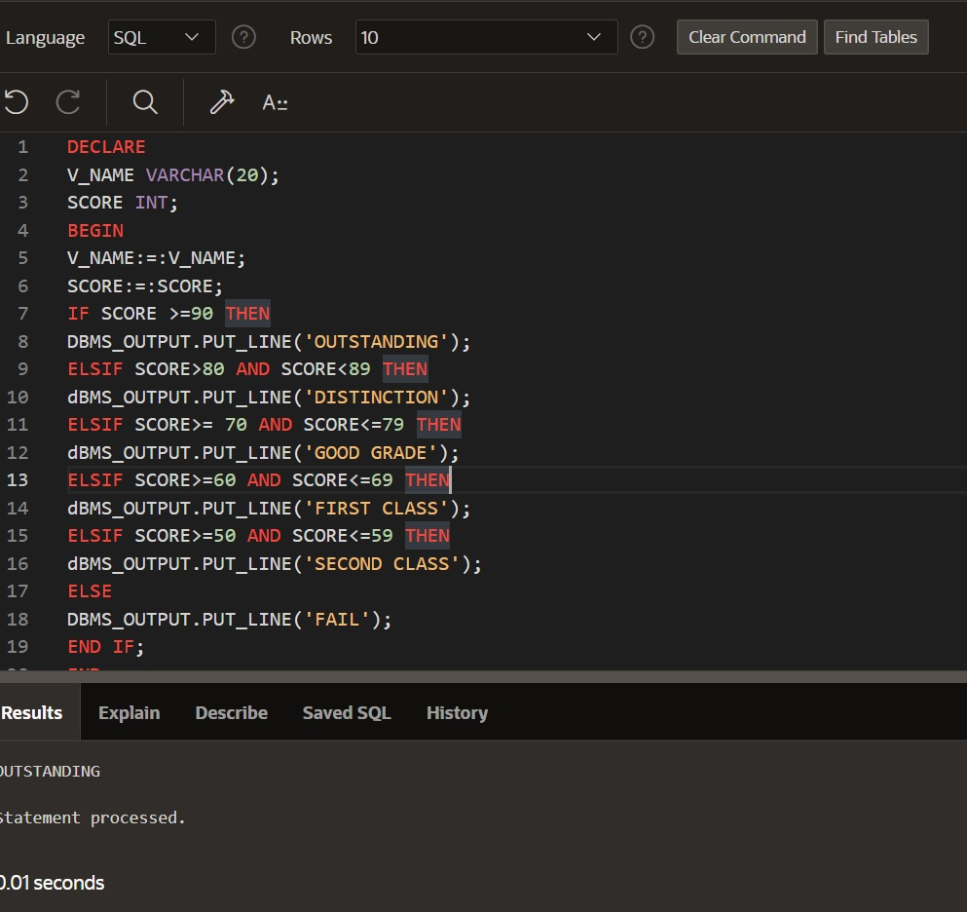

1. GRADING OF STUDENTS USING THE TABLE:

DECLARE CURSOR GRADE IS SELECT *FROM GRADING

FOR UPDATE;

BEGIN

FOR G IN GRADE

LOOP

IF G.STDMARKS>='90'THEN

UPDATE GRADING

SET STDGRADE='OUTSTANDING'

WHERE CURRENT OF GRADE;

ELSIF G.STDMARKS>='80'THEN

UPDATE GRADING

SET STDGRADE='DISTINCTION'

WHERE CURRENT OF GRADE;

ELSIF G.STDMARKS>='70'THEN

UPDATE GRADING

SET STDGRADE='GOOD GRADE'

WHERE CURRENT OF GRADE;

ELSIF G.STDMARKS>='60'THEN

UPDATE GRADING

SET STDGRADE='1ST CLASS'

WHERE CURRENT OF GRADE;

ELSIF G.STDMARKS>='50'THEN

UPDATE GRADING

SET STDGRADE='2ND CLASS'

WHERE CURRENT OF GRADE;

ELSE

UPDATE GRADING

SET STDGRADE='FAIL'

WHERE CURRENT OF GRADE;

END IF;

END LOOP;

END;

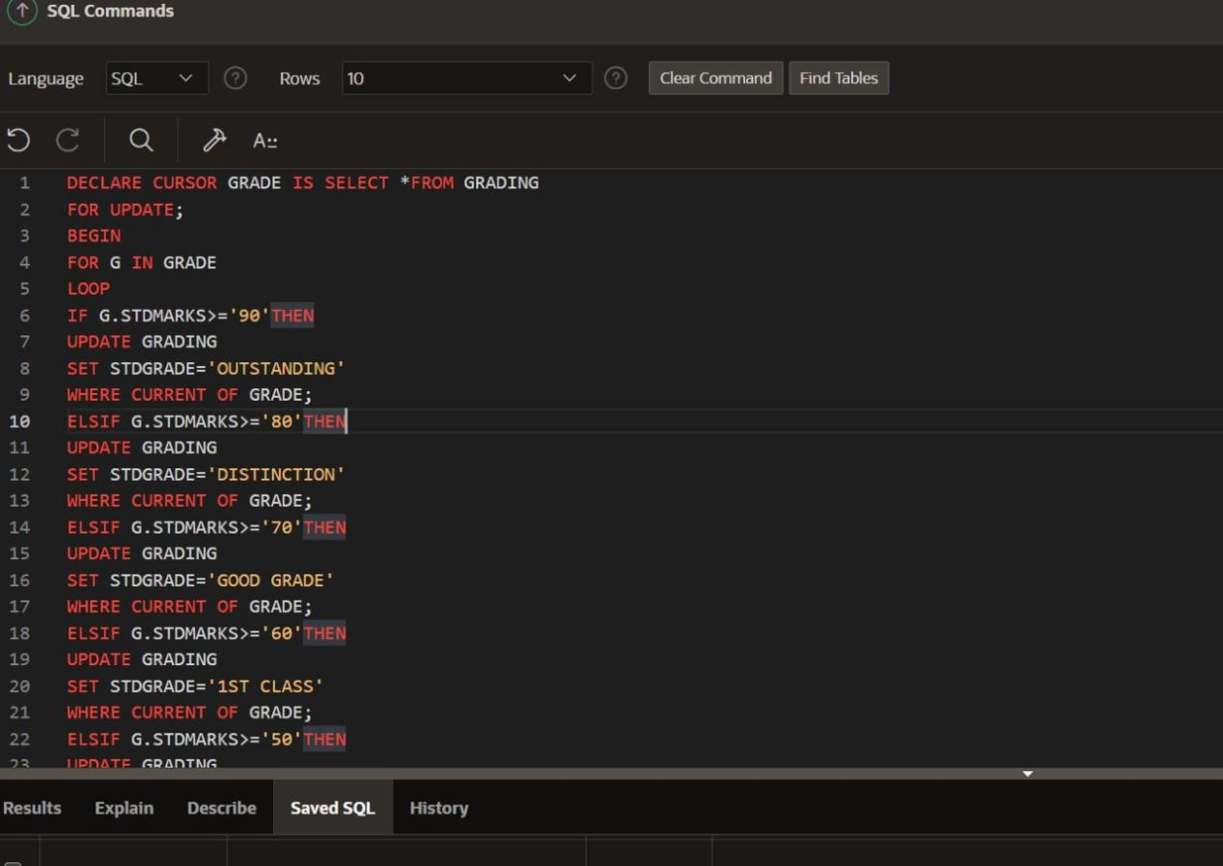

SELEECT * FROM GRADING;

